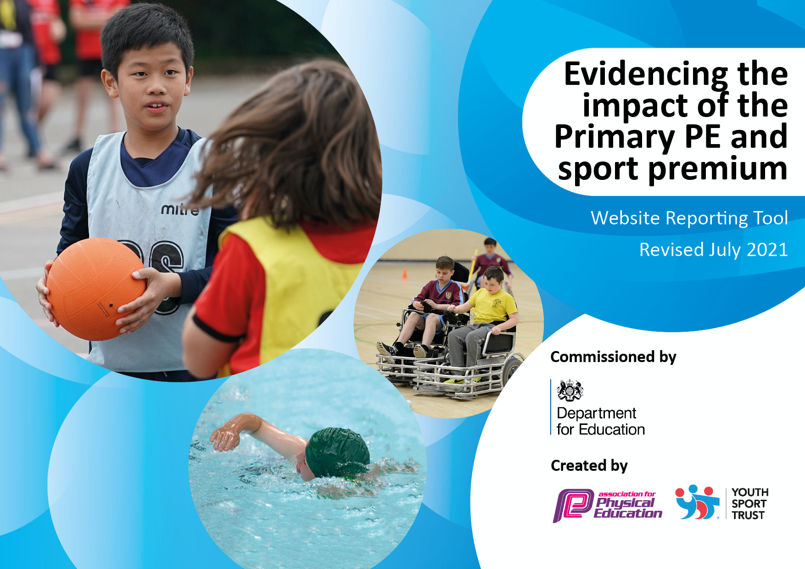
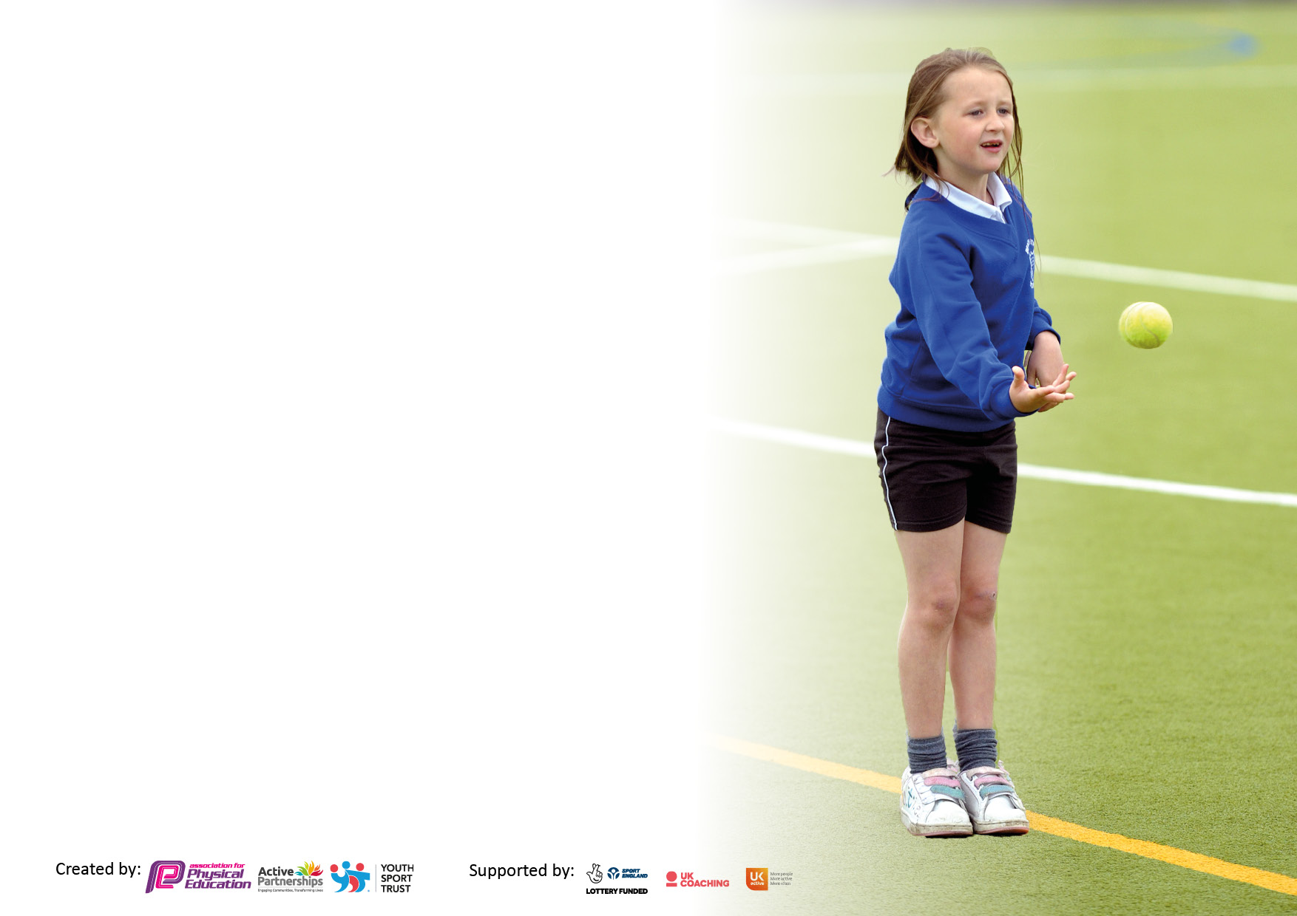

It is important that your grant is used effectively and based on school need. The Education Inspection Framework makes clear there will be a focus on ‘whether leaders and those responsible for governors all understand their respective roles and perform these in a way that enhances the effectiveness of the school’.

Under the Quality of Education Ofsted inspectors consider:
Intent - Curriculum design, coverage and appropriateness
Implementation - Curriculum delivery, Teaching (pedagogy) and Assessment
Impact - Attainment and progress

To assist schools with common transferable language this template has been developed to utilise the same three headings which should make your plans easily transferable between working documents.

Schools must use the funding to make additional and sustainable improvements to the quality of Physical Education, School Sport and Physical Activity (PESSPA) they offer. This means that you should use the Primary PE and sport premium to:

- Develop or add to the PESSPA activities that your school already offer
- Build capacity and capability within the school to ensure that improvements made now will benefit pupils joining the school in future years
- The Primary PE and sport premium should not be used to fund capital spend projects; the school’s budget should fund these.

Pleasevisitgov.ukfortherevisedDfEguidanceincludingthe5keyindicatorsacrosswhichschoolsshoulddemonstrate animprovement.Thisdocumentwillhelpyoutoreviewyourprovisionandtoreportyourspend.DfEencouragesschools to use this template as an effective way of meeting the reporting requirements of the Primary PE and sport premium.

We recommend you start by reflecting on the impact of current provision and reviewing the previous spend.

Schools are required to publish details of how they spend this funding, including any under-spend from 2019/2020, as well as on the impact it has on pupils’ PE and sport participation and attainment. All funding must be spent by 31st July 2022.

We recommend regularly updating the table and publishing it on your website throughout the year. This evidences your ongoing self-evaluation of how you are using the funding to secure maximum, sustainable impact. Final copy must be posted on your website by the end of the academic year and no later than the 31st July 2021. To see an example of how to complete the table please click HERE.
Created by: Supported by:

Details with regard to funding
Please complete the table below.

Total amount carried over from 2019/20 | £0
Total amount allocated for 2020/21 | £
How much (if any) do you intend to carry over from this total fund into 2021/22? | £0
Total amount allocated for 2021/22 | £16,990
Total amount of funding for 2021/22. To be spent and reported on by 31st July 2022. | £16,990
Swimming Data
Please report on your Swimming Data below.

Meeting national curriculum requirements for swimming and water safety.

N.B. Complete this section to your best ability. For example you might have practised safe self-rescue techniques on dry land which you can then transfer to the pool when school swimming restarts.
Due to exceptional circumstances priority should be given to ensuring that pupils can perform safe self rescue even if they do not fully meet the first two requirements of the NC programme of study
What percentage of your current Year 6 cohort swim competently, confidently and proficiently over a distance of at least 25 metres?  N.B. Even though your pupils may swim in another year please report on their attainment on leaving primary school at the end of the summer term 2021.  Please see note above | %NA
What percentage of your current Year 6 cohort use a range of strokes effectively [for example, front crawl, backstroke and breaststroke]?  Please see note above | %NA
What percentage of your current Year 6 cohort perform safe self-rescue in different water-based situations? | %NA
Schools can choose to use the Primary PE and sport premium to provide additional provision for swimming but this must be for activity over and above the national curriculum requirements. Have you used it in this way? | No

Action Plan and Budget Tracking
Capture your intended annual spend against the 5 key indicators. Clarify the success criteria and evidence of impact that you intend to measure to evaluate for pupils today and for the future.

 |  | Academic Year: 2020/21 |  |  | Total fund allocated: |  |  | Date Updated:
 |  | Key indicator 1: The engagement of all pupils in regular physical activity – Chief Medical Officers guidelines recommend that primary school pupils undertake at least 30 minutes of physical activity a day in school |  |  |  |  |  |  |  |  |  |  |  | Percentage of total allocation:
 |  |  |  |  |  |  |  |  |  |  |  |  |  | %
 |  | Intent |  |  | Implementation |  |  |  |  |  | Impact
 |  | Your school focus should be clear what you want the pupils to know and be able to do and about  what they need to learn and to  consolidate through practice: |  |  | Make sure your actions to achieve are linked to your intentions: |  |  | Funding allocated: |  |  | Evidence of impact: what do pupils now know and what can they now do? What has changed?: |  |  | Sustainability and suggested next steps:
 | To make staff and children aware of the 60 minute recommended guidelines and ensure that, where possible lessons include physically active learning in order to engage children in higher levels of Physical Activity (PA) throughout the school day;  Active Maths  Active Literacy |  |  | - Staff training – how to access and use the active learning website  - Develop a bank of resources and equipment that staff can access in order to increase physical activity in curriculum time. Active Maths & Active Literacy.  - Provide equipment to promote physical activity throughout the day as current equipment is not fit for purpose. |  |  | £975  NIL  £900 |  |  | Staff training- via zoom November 21  Staff more confident in using the active learning website and more confident to use resources.  Maths & Literacy lessons are more active (observations) |  |  | Physical activity will be part of the maths and literacy curriculum.
 | Balance bikes in reception  Bikeability |  |  | Maintain bikes  Provide bikeability for all classes |  |  | Nil  Nil |  |  | - Children will be able to use a bike safely.  - Improve road safety and build confidence  - Increase physical activity  - Improved balance and coordination  - Physical activity will be an integral part of learn through play session  - Children to cycle or scoot to school |  |  | Book bike ability for 2023
 | Promote the benefits of the daily mile and encourage staff and pupils to take part. |  |  | Organise a course and timetable for the daily mile. |  |  | Nil |  |  | - Improved fitness and well-being of both staff and pupils  - Daily mile embedded into school day |  |  | Ensure daily mile is timetabled for every class and it is embedded into the school day
 |  | To increase physical activity at break and lunchtimes |  |  | Provide trim tail equipment to promote physical activity throughout breaktimes. |  |  | £4130 |  |  | - Improved fitness & fun.  - Improved balance and coordination.  - Improve problem solving  - Increased core and upper body strength |  |  | Ensure safety is considered and ground is maintained so that it can be used most of the year.
 |  | Develop leadership with pupils and staff |  |  | Continue to develop sports leaders as part of PE curriculum in KS2.  Lunchtime staff training |  |  | Nil |  |  | Pupils will become sports leaders and good role models.  Leaders to provide activities for younger students. |  |  | Train all year 4’s to become leaders. Teach all children to respect and look after playground equipment.
 |  | Commando Joe Programme  To Teach the respect curriculum alongside physical activity |  |  | Each lesson is structured to give pupils the character tools and values they need to be successful in life such as resilience, determination, empathy and courage. |  |  | £1475 |  |  | Children will be more equipped to show respect, be resilient and take on more responsibility and challenge. |  |  | Ensure cojo equipment is all useable.
 |  | Key indicator 2: The profile of PESSPA being raised across the school as a tool for whole school improvement |  |  |  |  |  |  |  |  |  |  |  | Percentage of total allocation:
 |  |  |  |  |  |  |  |  |  |  |  |  |  | %
 |  | Intent |  |  | Implementation |  |  |  |  |  | Impact
Your school focus should be clear what you want the pupils to know and be able to do and about  what they need to learn and to  consolidate through practice: |  |  | Make sure your actions to achieve are linked to your intentions: |  |  | Funding allocated: |  |  | Evidence of impact: what do pupils now know and what can they now do? What has changed?: |  |  | Sustainability and suggested next steps:
To ensure High quality PE teaching and learning across the school.  Teachers to increase their subject knowledge and confidence. |  |  | Teachers to shadow NU Foundation staff and upskill their knowledge and teaching methods.  Teachers will have a better understanding of the fundamentals of PE and be more confident in delivery of physical education.  Dedicate at least one meeting for training per term. |  |  | £3170 |  |  | The sports coaches /teachers employed by NU Foundation are key members of Tweedmouth West First school team. They work alongside class teachers to provide outstanding PE sessions. Skills, knowledge and understanding of pupils and staff are increased.  Through assessment children and staff will have a good awareness of levels of competence and how to improve. |  |  | - Subscribe to AFPE membership to support teachers with their PE lessons.  - Complete staff survey to ensure staff are getting the support that they need and provide them with extra resources that they may need.  - Ensure new member of staff is familiar with our curriculum and provide support where necessary
 |  | To continue to raise the profile of school sport and physical literacy.  To share our mission with school & partnership staff as well as parents and pupils.  To imbed and enable the children to make informed choices about physical activity throughout their lives. |  |  | Highlight PE in staff meetings once a term.  Provide PE training to all staff.  Provide governors training.  Share or PE policy & mission on our website. |  |  | Nil |  |  | All school staff will hold PE highly in their mindset.
 |  | PE website/notice boards to be regularly updated so that information on there is current and celebrates all types of achievements in sport and physical activity. |  |  | Celebrate personal achievements –  Within school and out of school on the website, displays, parent mail and social media. |  |  | NIL |  |  | Children will be inspired and be motivated to achieve their personal best.

Key indicator 3: Increased confidence, knowledge and skills of all staff in teaching PE and sport |  |  |  | Percentage of total allocation:
 |  |  |  | %
Intent | Implementation |  | Impact
Your school focus should be clear | Make sure your actions to | Funding | Evidence of impact: what do | Sustainability and suggested
what you want the pupils to know | achieve are linked to your | allocated: | pupils now know and what | next steps:
and be able to do and about | intentions: |  | can they now do? What has
what they need to learn and to |  |  | changed?:
consolidate through practice:
To ensure high quality PE teaching and learning across the school.  Teachers to increase their subject knowledge and confidence. | Teachers to shadow NUFoundation staff to upskill their knowledge and  delivery.  Teachers will have a better understanding of PE and be more confident in delivery of physical education.  Dedicate at least one meeting for training per term. | £3170 | The sports coaches /teachers from NUFoundation are key members of Tweedmouth West First School team.  They work alongside class teachers to provide outstanding PE sessions.  Skills, knowledge and understanding of pupils and staff is increased.  Through assessment, children and staff will have good awareness of levels of competence and how to improve. | - Staff will become physically literate.  - Staff will be more confident.  - They will have a better understanding of the wider effect of physical activity on children’s wellbeing – confidence in assessment and feedback.
Key indicator 4: Broader experience of a range of sports and activities offered to all pupils |  |  |  | Percentage of total allocation:
Intent | Implementation |  | Impact
Your school focus should be clear | Make sure your actions to | Funding | Evidence of impact: what do | Sustainability and suggested
what you want the pupils to know | achieve are linked to your | allocated: | pupils now know and what | next steps:
and be able to do and about | intentions: |  | can they now do? What has
what they need to learn and to |  |  | changed?:
consolidate through practice:
To be physically literate and use this to develop their love of sport beyond the school gates.  To provide all children with the fundamental skills to take part in a broad range of sports.  Give children the opportunity through lessons, extracurricular and community clubs to experience a wide range of activities/sports.  Provide opportunities to inspire pupils to achieve their personal best. | Provide a broad curriculum that can progress to local/area clubs. Collate a bank of information about local clubs and activities which link to the after-school clubs being  offered. Signpost parents/children towards local clubs via parent mail, website and social media. Weekly slot in celebration assembly to celebrate school sport taking place outside of school.  To create a sports crew that not only includes playground leaders but also children who want to create competitions, officiate games and potential journalists. | £3170  NIL  Nil | More children will achieve the expected 60 minutes of physical activity per day or more. | ½ termly survey to assess activity levels in and out of the school day.  Timetabled meetings to develop a sports crew and give pupil voice

Key indicator 5: Increased participation in competitive sport |  |  |  | Percentage of total allocation:
 |  |  |  | %
Intent | Implementation |  | Impact
Your school focus should be clear | Make sure your actions to | Funding | Evidence of impact: what do | Sustainability and suggested
what you want the pupils to know | achieve are linked to your | allocated: | pupils now know and what | next steps:
and be able to do and about | intentions: |  | can they now do? What has
what they need to learn and to |  |  | changed?:
consolidate through practice:
Offer a variety of competition;  - Personal best  - Festivals  - Intra school competition  - Inter school competition | Plan competition into lessons.  Yearly competition timetable to include;  Festivals  Intra competition  Inter competition | Nil | All children will have an understanding of how to achieve their oven personal best.  All children will have taken part in at least one intra school competition. | Plan intra school competition timetable.  Plan inter school competition timetable with SGO and NU Foundation manager.

Signed off by
Head Teacher:
Date:
Subject Leader: | Julie Pick
Date: | 18th July 2022
Governor:
Date:

